**Software Project Management Plan**

**SPMP**

**Name: Abdulaziz Bahman**

**Roll Number**

**Inventory Management System**

Contents

Introduction 3

Objectives 3

Functions 3

Performance issues 3

Constraints 4

Project estimates 4

Historical data used 4

Estimation techniques details 4

Cost, duration, effort estimates 4

Project Schedule 5

Work breakdown 5

Gantt and PERT chart 5

Project resource 6

Manpower 6

Hardware and Software 6

Front End: 6

Back End: 7

Functionality: 7

Staff organization 9

Team formation and structure 9

Management reporting 9

Risk Management 9

Risk analysis 9

Risk identification 9

# Introduction

## Objectives

The objective of the project is to provide an inventory management system for the stores and organizations working around the globe. This project will be providing an easy to use software application for the organizations and companies helping them manage the overall inventory in a much effective way.

## Functions

We have defined functions based on the stakeholders for the project. These functions can be listed as

1. The store managers would be able to add a product, add consignment of the existing product and remove the specific quantity of the specific items. Also store managers would be able to generate the send out order for the specific shipment, which would be processed by the delivery services.
2. Web admin will be able to add and remove store manager accounts, update their details and addresses. These details will be fetched from the database when the specific store manager logs in.
3. Delivery services will only read data from the application about the shipments to be sent. This will be used for the purpose of delivery of the items on time. After the delivery, they will be notifying the store manager about the delivery made so that he can update the overall inventory accordingly.

## Performance issues

One problem that can be seen is the overall synching of the application for different stores. Such as, two different store managers making an entry at the same time will force the application to decide based on the priorities set for the store managers and the other store manager will be informed respectively.

## Constraints

One such constraint that can be faced during the project is the hosting of the website online. Online hosting usually involves a number of complication that can be faced during the implementation process. This may also include the prices to be paid for the hosting of website online.

# Project estimates

## Historical data used

We will be analyzing the similar inventory system working around the globe in order to provide a better understanding of the functionalities that can be added or the working of the functionalities that are being implemented in our project.

## Estimation techniques details

We will be using the Top-Down estimate process. As we are aware of the overall time period provided to build the whole project. We will be dividing this time period into three major parts for the implementation of the three different sections of the project being

1. Front End
2. Back End
3. Functionality

## Cost, duration, effort estimates

The overall project will not be involving any cost as the project is being made on the local servers by the group members. The only cost that will be involved, will be the cost of hosting of the website on the servers if required. We will be trying to complete the overall project before the deadline provided with the maximum effort provided in the project.

# Project Schedule

## Work breakdown

## Gantt and PERT chart

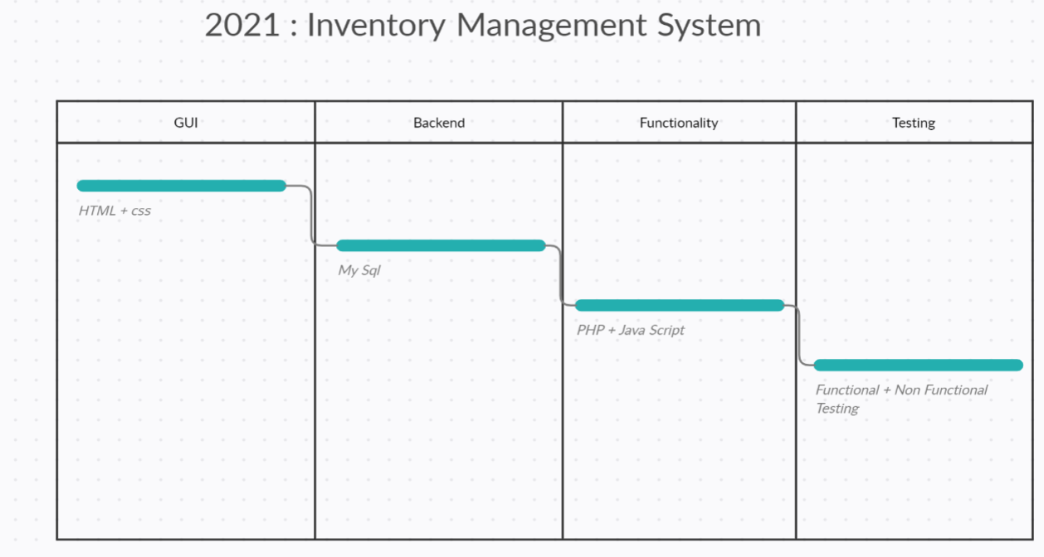

# Project resource

## Manpower

All the team members will be working in the development of the project and will be equally involved in the production in each process.

## Hardware and Software

This is a web based project, hence we will only be using different languages and frameworks for the development that can be listed as

### Front End:

Front End refers to what we see on the screen such as the User Interface. This will be made by using two major components being

#### HTML:



The Hypertext Markup Language, or HTML is the standard markup language for documents designed to be displayed in a web browser.

#### CSS:



Cascading Style Sheets is a style sheet language used for describing the presentation of a document written in a markup language such as HTML.

### Back End:

Backend majorly consists of the database that stores all the information for a specific application. For the purpose of database, we will be using only a single database being

#### MySQL:



MySQL is an open-source relational database management system.

### Functionality:

This is the middle layer that joins the front end with the back end and performs most of the actions for the application. For the purposing of adding such functionalities we require scripting languages that we have selected two different for the application. A combination of both will be used for the purpose of project.

#### PHP:



PHP is a general-purpose scripting language especially suited to web development.

#### JavaScript:



JavaScript, often abbreviated as JS, is a programming language that conforms to the ECMAScript specification. JavaScript is high-level, often just-in-time compiled, and multi-paradigm.

# Staff organization

## Team formation and structure

All the team members will be working in the development of the project and will be equally involved in the production in each process.

## Management reporting

There will be no manager, and all the team member will be working in coordination with each other.

# Risk Management

## Risk analysis

There can be a number of risks as linked with the inventory management system such as a hacker getting access to the information or the DDOS attack on the servers to make the website useless.

## Risk identification

Thus the overall risks can be identified as

1. Hacker attacks
2. DDOS attacks
3. Malwares in the software